Exploratory Data Analysis and Visualization in Agribusiness
Week 3 Task | Junior Data Analyst - Agribusiness Internship | Yuva Intern

1. Introduction
This report performs exploratory data analysis (EDA) on the Crop-Wise Area, Production and Yield (APY) dataset introduced in Week 1 and cleaned in Week 2 (455,359 raw rows; 450,350 rows post-cleaning, with is_outlier and crop_failure flags). The analysis focuses on crop yield distributions, the relationship between cultivated area and production, and yield trends over time (1997-2023), in place of weather and market-price variables, since those require separate data sources not yet integrated into this cleaned dataset (see Section 8, Recommendations, for a plan to incorporate them). A recurring theme emerged across every analysis performed: statistics computed across all crops combined are frequently misleading, and must be segmented by crop to be meaningful. This theme, and five specific evidenced findings, are detailed below.

2. Methodology
All analysis was performed in a Jupyter notebook using pandas and matplotlib, using the cleaned dataset carried forward from Week 2. Unless otherwise stated, is_outlier and crop_failure flagged rows were explicitly excluded before computing summary statistics, distributions, and correlations (consistent with the 'typical-performance' usage defined in Week 2, Section 4.7), so that genuine extreme events do not distort the baseline patterns being identified here.
import pandas as pd
df_clean = pd.read_csv('cleaned_apy_data.csv')
benchmark = df_clean[~df_clean['is_outlier'] & ~df_clean['crop_failure']]

3. Summary Statistics: All-Crop vs. Per-Crop
The dataset's yield column was first summarized across all crops combined:
print(df_clean['yield'].describe())
# count 450350, mean 69.61, std 866.46, min 0.0
# 25%: 0.579, 50% (median): 1.070, 75%: 2.586, max: 43958.33
The mean (69.6) is dramatically higher than the median (1.07) - a classic signature of extreme right-skew. Grouping by crop_name explains why:
crop_stats = df_clean.groupby('crop_name')['yield'].agg(['mean','std','median'])
print(crop_stats.sort_values('mean', ascending=False).head(5))
# Coconut: mean=8974.70 std=4852.36 median=8140.55
# Sugarcane: mean=58.73 std=61.01 median=56.19
# Banana: mean=30.69 std=21.11 median=26.09
Coconut's mean yield is over 150 times higher than the next-highest crop (Sugarcane), single-handedly explaining the all-crop mean/median mismatch. This confirms a principle already established during Week 2's outlier-cleaning work: crop-level segmentation is required for any statistic to be meaningful on this dataset, not just for outlier detection.

4. Distribution Analysis
Yield distributions were visualized for four staple crops (Wheat, Rice, Maize, Sugarcane), with flagged outlier and crop-failure rows excluded, to observe each crop's genuine shape in isolation from both cross-crop scale differences and extreme values.
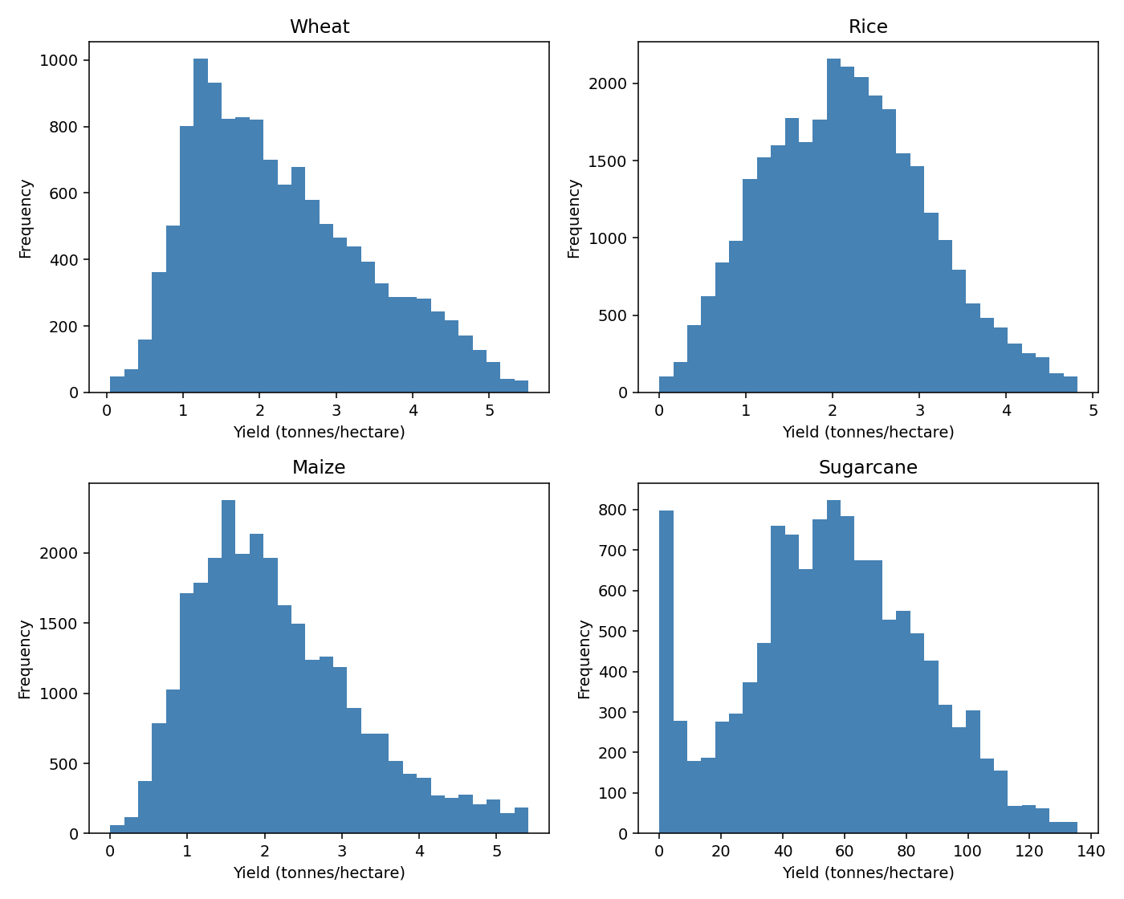
Figure 1: Per-crop yield distributions (outliers and crop failures excluded). Wheat, Rice, and Maize each show a clean right-skewed shape; Sugarcane (bottom-right) remains visibly bimodal.
Wheat, Rice, and Maize each produced a clean, right-skewed single-peak distribution once flagged rows were excluded - a healthy, expected shape for an agricultural yield variable. Sugarcane was the exception: even after excluding flagged rows, it retained two distinct humps, one near zero and a separate peak around 40-80 tonnes/hectare, rather than one smooth shape.
This was investigated directly, rather than dismissed as noise:
near_zero = df_clean[(df_clean['crop_name']=='Sugarcane') & (df_clean['yield']<5)]
print('Rows:', len(near_zero), '| crop_failure:', near_zero['crop_failure'].sum(), '| is_outlier:', near_zero['is_outlier'].sum())
# Rows: 869 | crop_failure: 42 | is_outlier: 0 -> 827 rows are genuine, unflagged low-yield data
print(near_zero['state_name'].value_counts().head())
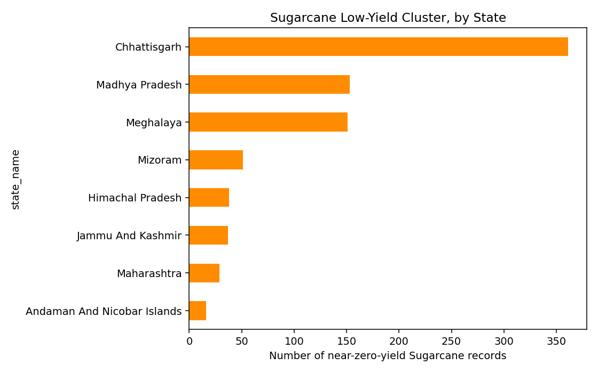
Figure 2: States contributing most to Sugarcane's near-zero-yield cluster.
Of the 869 near-zero Sugarcane rows, only 42 were flagged as crop failures and none as statistical outliers - meaning 827 rows are genuine, valid data points, not errors. These rows concentrate in Chhattisgarh, Madhya Pradesh, and north-eastern hill states (Meghalaya, Mizoram, Himachal Pradesh) - regions generally associated with smaller-scale, rain-fed cultivation rather than the irrigated commercial Sugarcane belts (e.g., Uttar Pradesh, Maharashtra). This supports treating Sugarcane's bimodal shape as evidence of two distinct production systems, not a data quality defect requiring further cleaning.

5. Correlation Analysis
The relationship between cultivated area and production was tested, first across all crops combined:
correlation = df_clean['area'].corr(df_clean['production'])
print(correlation)
# 0.0424
A correlation of 0.04 is close to zero - counter-intuitive, since more land under cultivation should generally produce more output. Following the same logic as Sections 3-4, this was re-tested within individual crops:
for crop in ['Wheat','Rice','Maize','Sugarcane']:
data = df_clean[df_clean['crop_name']==crop]
print(crop, ':', data['area'].corr(data['production']))
# Wheat: 0.936 | Rice: 0.898 | Maize: 0.852 | Sugarcane: 0.929
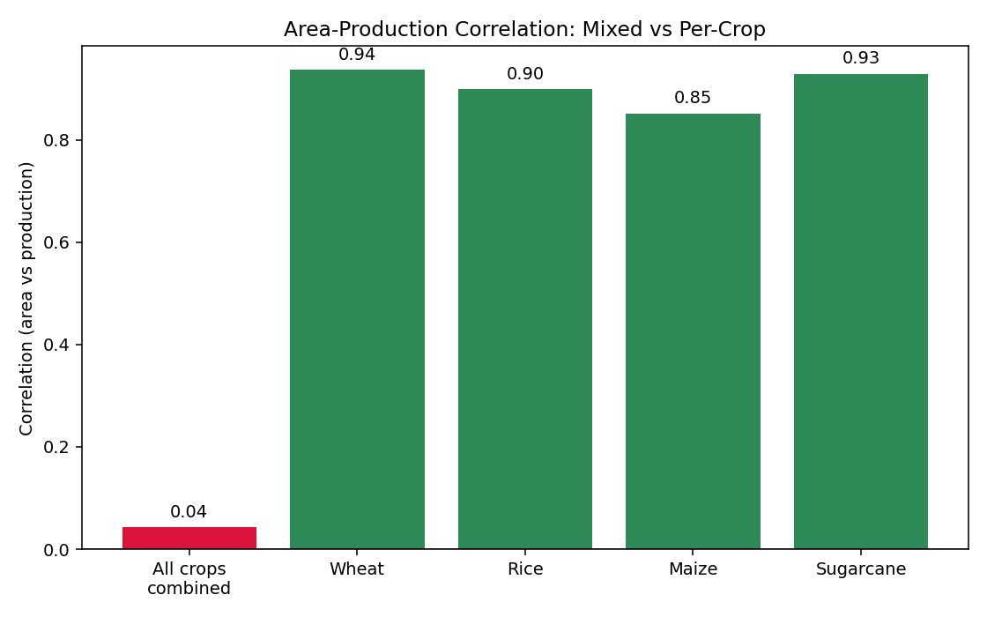
Figure 3: Area-production correlation collapses when all crops are combined (0.04), but is consistently strong (0.85-0.94) within each individual crop.
All four staple crops show strong positive correlation (0.85-0.94) between area and production when considered individually - confirming the expected agronomic relationship. The near-zero figure for all crops combined is an artifact of mixing crops with very different area-to-production ratios (e.g., one hectare of Coconut vs. one hectare of Wheat), not evidence that area and production are actually unrelated. This is the same underlying lesson as Sections 3 and 4, now shown to apply to correlation analysis as well as to summary statistics and distributions.

6. Yield Trend Over Time
Yearly mean yield was first computed across all crops combined:
df_clean['year_start'] = df_clean['year'].str[:4].astype(int)
yearly_avg = df_clean[~df_clean['is_outlier'] & ~df_clean['crop_failure']].groupby('year_start')['yield'].mean()
# 1997: 45.59 -> 2022: 81.72 (apparent ~79% increase)
This suggested a dramatic near-doubling of yield over 25 years. Given the pattern established in every prior section, this was tested against a single-crop trend before being trusted:
wheat_yearly = df_clean[(df_clean['crop_name']=='Wheat') & (~df_clean['is_outlier']) & (~df_clean['crop_failure'])].groupby('year_start')['yield'].mean()
# 1997: 1.904 -> 2022: 2.726 (+43.2%)
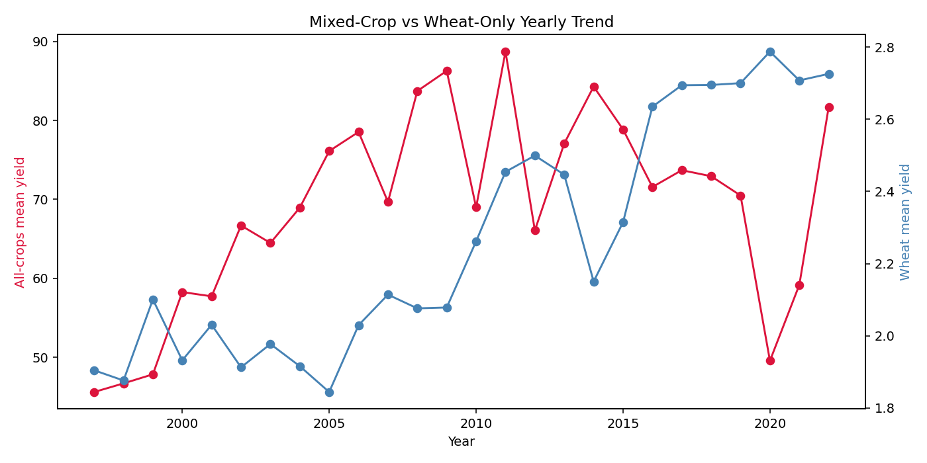
Figure 4: The mixed-crop yearly trend (red, left axis) rises far more steeply than the Wheat-only trend (blue, right axis) - the mixed-crop version overstates real productivity growth due to shifting crop composition over time.
Wheat alone shows a real, more modest productivity gain of 43.2% over 25 years (1.90 to 2.73 tonnes/hectare) - plausible given known improvements in seed varieties and irrigation access over this period. The mixed-crop figure (+79%) overstates this, most likely because the proportion of high-yield crops (e.g., Coconut) reported in the dataset shifted over time, inflating the blended average independent of any single crop's actual improvement.
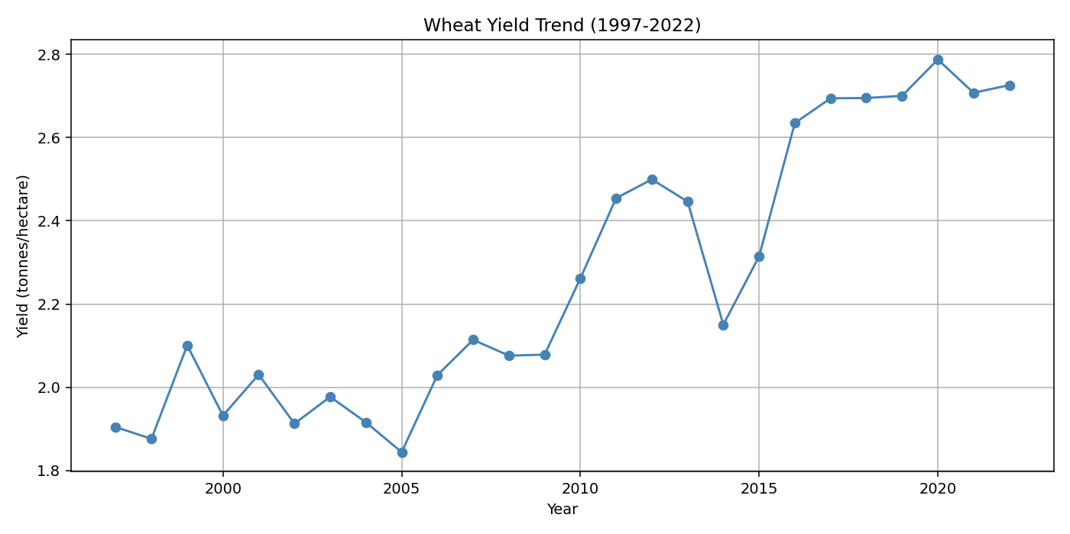
Figure 5: Wheat yield trend, 1997-2022, isolated from other crops. Growth is not linear - a flat period (1997-2009), a rise (2010-2012), a sharp dip (2014), then the steepest sustained rise (2015-2020).
The Wheat-only trend is not a smooth line: it includes a sharp single-year dip in 2014, which was investigated further rather than treated as noise.
for yr in [2012,2013,2014,2015,2016]:
yd = df_clean[(df_clean['crop_name']=='Wheat') & (df_clean['year_start']==yr) & (~df_clean['is_outlier']) & (~df_clean['crop_failure'])]
g = yd.groupby('state_name')['yield'].mean()
print(yr, g.get('Uttar Pradesh'), g.get('Punjab'), g.get('Madhya Pradesh'))
# Uttar Pradesh: 3.22 (2013) -> 2.07 (2014) -> 2.77 (2015) -> 3.56 (2016)
# Punjab and Madhya Pradesh remained comparatively stable across the same years
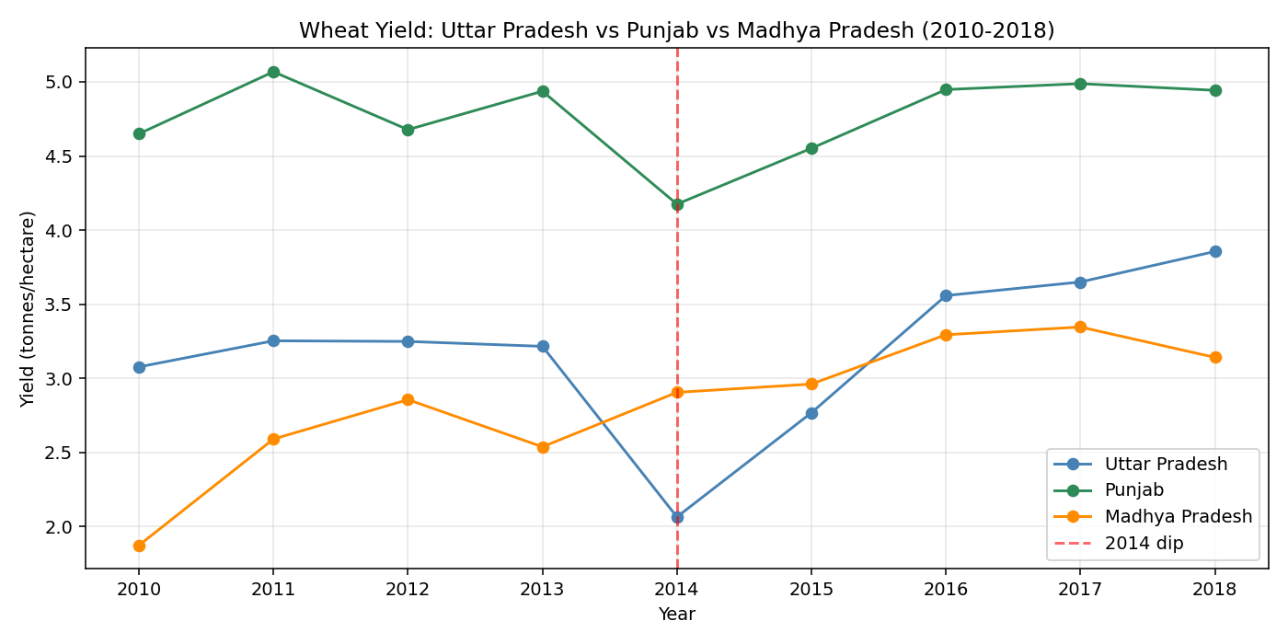
Figure 6: The 2014 Wheat yield dip was concentrated in Uttar Pradesh; Punjab and Madhya Pradesh remained comparatively stable over the same period.
The 2014 national dip was driven almost entirely by Uttar Pradesh, India's largest wheat-producing state by volume, where yield fell sharply before recovering by 2016. Punjab and Madhya Pradesh - two other major wheat states - did not show a comparable drop. This demonstrates that a national yield figure can be disproportionately influenced by conditions in a single dominant-producing state.

7. Summary of Findings and Business Implications
Finding | Evidence | Scope | Business Implication
Mixed-crop statistics are misleading | Mean yield 69.6 vs. median 1.07 (all crops); Coconut mean (8,974.7) is 150x+ the next crop | All 450,350 rows, 1997-2023 | Any report or dashboard presenting a single national 'average yield' figure should be treated with caution unless segmented by crop
Area-production correlation is crop-dependent | 0.04 (all crops combined) vs. 0.85-0.94 (per staple crop) | Wheat, Rice, Maize, Sugarcane | Land-use planning and procurement forecasting models must be built per-crop, not as one blended model
Sugarcane yield is genuinely bimodal | Distinct low-yield cluster (<5 t/ha) concentrated in Chhattisgarh, Madhya Pradesh, NE hill states | Sugarcane, all years | Suggests irrigation-infrastructure investment opportunity in rain-fed Sugarcane-growing regions
Wheat shows a real, moderate productivity gain | 1.90 to 2.73 t/ha (+43.2%), 1997-2022, after removing flagged rows | Wheat only | Supports continued investment in seed-variety and irrigation programs that likely drove this gain
National yield figures can be driven by one state | 2014 national Wheat dip traced to Uttar Pradesh (3.22 to 2.07 t/ha); Punjab and MP stable | Wheat, 2012-2016, by state | Supports state-level (not just national-level) weather/yield monitoring and insurance design

8. Recommendations for Further Analysis
1. Incorporate weather data
- The current dataset has no weather variables. Joining district-level rainfall/temperature data (e.g., IMD, identified in Week 1) against the 2014 Uttar Pradesh dip specifically would help confirm or rule out a weather-driven cause, rather than leaving it as a plausible but unconfirmed hypothesis.
2. Incorporate market price data
- Joining Agmarknet-style price data (identified in Week 1) against yield would allow testing whether the 2014 Uttar Pradesh yield dip corresponded with a price spike - a direct test of the supply-and-price relationship central to agribusiness decision-making.
3. Extend the per-crop approach to all remaining crops
- This report focused on four staple crops for depth. Running the same distribution and correlation checks across all ~50 crop_name values in the dataset (automatable via the groupby patterns already used throughout this report) would systematically surface any other crops with a Sugarcane-like bimodal pattern or an unusually weak area-production correlation.
4. Investigate the Sugarcane regional split further
- The regional hypothesis (rain-fed vs. irrigated cultivation) was supported by state concentration but not directly confirmed. Cross-referencing against an irrigation-coverage dataset by district would either confirm or refute this explanation with direct evidence rather than inference.

9. Challenges Faced and Strategies Used
Analytical challenges
- The single most recurring challenge was the temptation to trust an all-crop aggregate statistic at face value. This occurred independently in three separate places - the overall yield summary (Section 3), the area-production correlation (Section 5), and the yearly trend (Section 6) - each initially producing a misleading or counter-intuitive result that was only resolved by re-running the same calculation segmented by crop. Strategy: treating any surprising or counter-intuitive all-crop statistic as a prompt to re-check it per-crop, rather than accepting the first result.
- The Sugarcane bimodal distribution could have been mistaken for a data quality issue needing further cleaning, especially since it resembled the kind of pattern addressed in Week 2. Strategy: before applying any further cleaning, the flags already created in Week 2 (is_outlier, crop_failure) were checked against the affected rows directly, confirming the pattern was not flagged data - which redirected the investigation toward a genuine regional/agronomic explanation instead of further data cleaning.
Technical/implementation challenges
- Partway through this task, loading the cleaned dataset raised a KeyError for crop_failure despite the file existing. Investigation showed the CSV had been regenerated from the raw file without re-attaching the is_outlier and crop_failure columns created in Week 2 - the same class of column-missing error encountered during Week 2's debugging, now occurring one level up, when a cleaned export file itself can get out of sync with the notebook that produced it. Strategy: regenerating the cleaned CSV from the full Week 2 cleaning sequence (dropna, then both flag columns) before continuing, and verifying df_clean.columns included both flags before relying on them further.
- The first attempt at visualizing per-crop yield distributions plotted all four staple crops on one shared chart, which rendered three of them as flat lines near zero, since Sugarcane's scale dominated the shared x-axis - directly analogous to the global-vs-per-crop outlier problem from Week 2. Strategy: switching to separate subplots (one per crop, each with its own x-axis scale), which is the visualization equivalent of the per-crop grouping fix applied in Week 2.

10. Conclusion
This EDA task identified five concrete, evidenced findings in the cleaned APY dataset: mixed-crop yield statistics are misleading due to extreme cross-crop scale differences (e.g., Coconut vs. Wheat); area-production correlation is strong within a crop (0.85-0.94) but collapses when crops are combined (0.04); Sugarcane's yield distribution is genuinely bimodal, concentrated in specific likely rain-fed states; Wheat shows a real, moderate 43.2% yield improvement over 25 years once isolated from other crops; and a 2014 national Wheat yield dip was traced to a single dominant-producing state, Uttar Pradesh. A single theme ties these together: every reliable finding in this report required segmenting by crop (and in one case, by state) before trusting an aggregate number - a principle carried forward from Week 2's outlier-cleaning work and now shown to generalize across distributions, correlation, and time-trend analysis alike. Recommendations for Week 4 center on incorporating weather and price data to test the hypotheses raised here with direct evidence, rather than inference alone.

